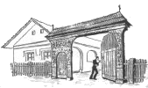
Hungarian Cultural Center of Northeastern Ohio
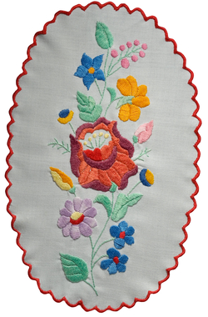
Presents
Summer 2014 KidsZone Series for Children & Teens
Held during Picnics on
June 22, July 20, August 17,
and September 14
Approximately 2:00 pm – 4:00 pm
Picnic hours are 11 am – 7 pm in June and
Noon – 7 pm in July, August and September
Get a different taste of Hungarian heritage
at each picnic, including:
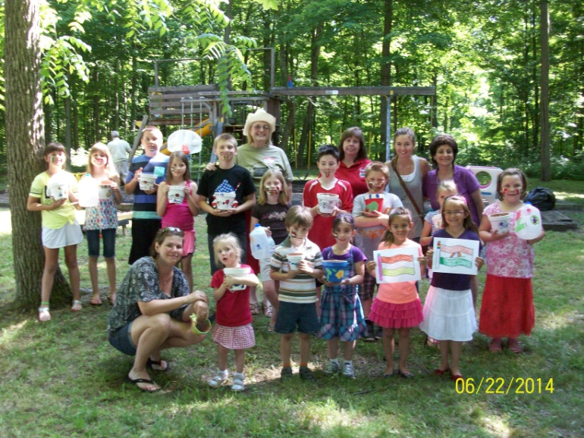
- Learn colors, how to count, or names of everyday items in Hungarian
- Enjoy Hungarian-themed crafts
- Participate in games, songs, or dances
- Work on your soccer skills
- Hear Hungarian stories
(told in English)
- And more!
*Specific activities vary by date
NO additional cost for KidsZone!
Entrance fee for the picnic: $5.00 per person at the gate; kids under 12 FREE.
Hungarian Cultural Center of Northeastern Ohio
12027 Abbott Road - Hiram OH 44234 330-274-2786 www.hungarianclub.org

